CSCE 572

Group 7

Usability Test Progress

3 methods:

1. Survey

**Implementation:** We talked about and decided on the most important questions we had regarding the redesign of our website. We formatted these questions into various open response-option, closed-response, open-ended, and likert scale questions based on how someone could best answer them. We received many responses containing very useful info.

**Data collected:** The first several questions in the survey helped us determine key functions to implement, as well as what features of a hotel customers like to see. The last couple questions dealt with the visual design and what the participants found appealing/off-putting. We also collected class standing (junior, senior, etc.) to see if that affected opinions on the website.

**Summarize Data:** 75% of respondents said they appreciated the simple and easy layout of all the information on the pages. Equally, 75% of respondents also said their biggest grievance with the site was our design (either color scheme or choice of font). This shows us that functionally, people like our site. However, we need to make the site more visually appealing for our users.

1. Card sorting

**Implementation:** We will use card sorting in order to find the best possible way to organize all of the search filters of Trivago. Currently there is a ton of filters, and we are struggling to group them in any meaningful way. Thus we will use the open sort version of card sorting in order to discover ways of organizing the information. We will implement this method by writing all of the search filters individually on index cards and then ask our fellow students to sort them into groups based upon their similarities. Once that is finished we will then provide them with blank index cards and ask them to name each group that they created.

**Data Collection:** In all we had 7 people participate in our card sorting evaluation. Among the participants, there were a few ideas common among all of the evaluators. In the majority of the sorts there was a group that listed everything found in the hotel room, usually labeled amenities. Then there was also a group usually labeled Rest and Relaxation which included all the different spa and bath options provided at the hotel. Most groups also had some kind of food related group labeled restaurants or something similar. The following example shows off some of the most common categories that we received. The rest of the card sort information can be found in the appendices section A.

**Data Example:**

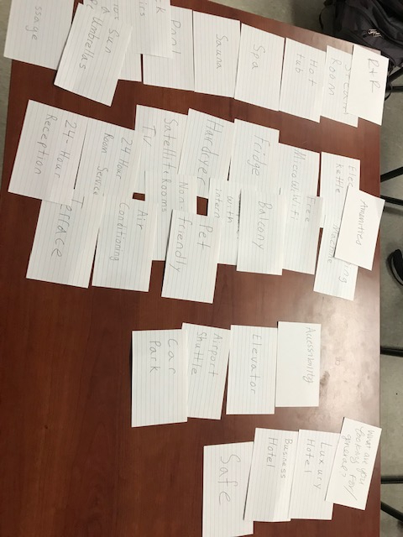

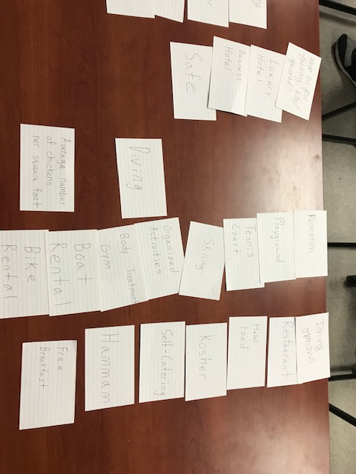

1. Heuristic Evaluation

**Implementation:**

Heuristic Evaluation is a process that requires the evaluator’s knowledge of Heuristics and a functional prototype. Implementing a Heuristic Evaluation was easy for a class of HCI students. The most important step was to make sure the participant had fundamental knowledge of Jakob Neilson’s Heuristics. Once that was assured we let them test the prototype we have against the Heuristic rules given. Once the user felt they had tested our project thoroughly, they were instructed to rate the violated heuristics by severity and give details on the specific issue.

**Data Collection:**

The data we gathered is the result of 3 Heuristic Evaluations. In most usability tests this would be not big enough of a test group; however, Heuristic Evaluations provide enough detail that 3 users can give a sufficient usability test. Below is the data quantified:

**Data Results:**

|  |  |  |
| --- | --- | --- |
| **Heuristic User Chose** | **How Many Times Chosen** | **Average Severity** |
| **1** | **2** | **3** |
| **3** | **3** | **5** |
| **4** | **2** | **1** |
| **6** | **1** | **2** |
| **7** | **1** | **2** |
| **8** | **4** | **3** |
| **10** | **1** | **4** |

**Summarize Data:**

Two common concerns that came out of this evaluation were color scheme and the search bar. In reference to the search bar, it provided a lack of feedback and lacked some key features other search bars had, namely autocorrect. Another common criticism came with the button layout, mainly involving the overwhelming and overlapping choices provided with our schema.

**Appendices.**

1. **The Card Sorting Data**

Participant 1:





Participant 2

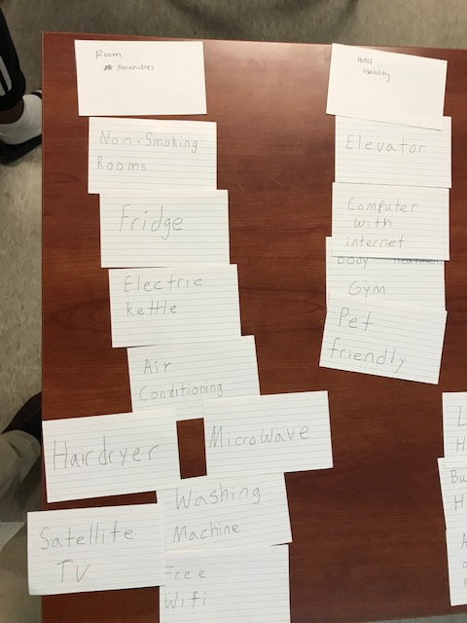 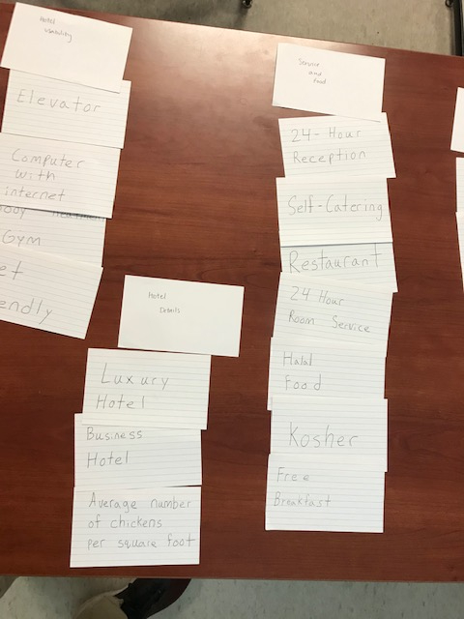

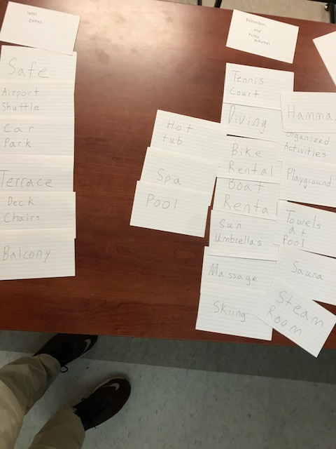

Participant 3

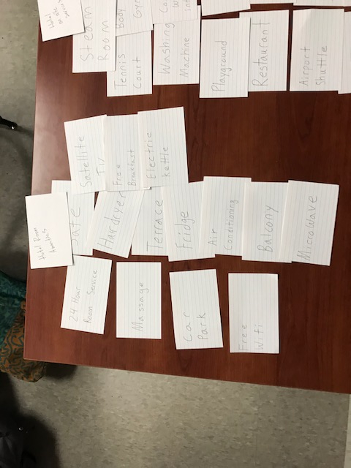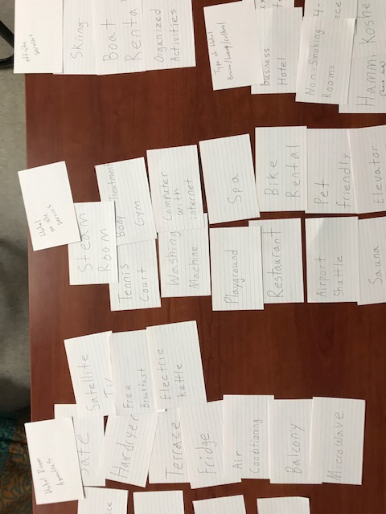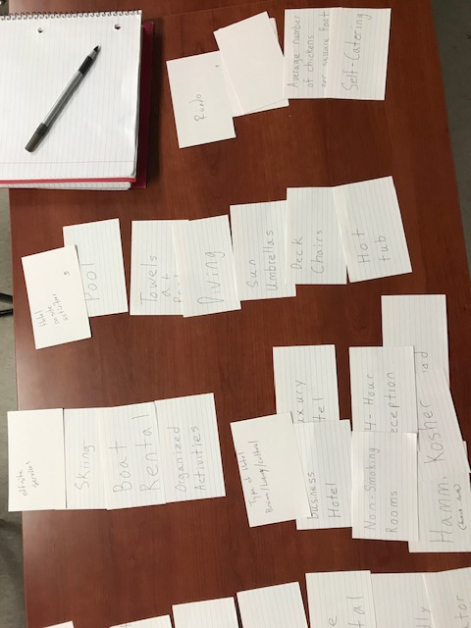

Participant 4

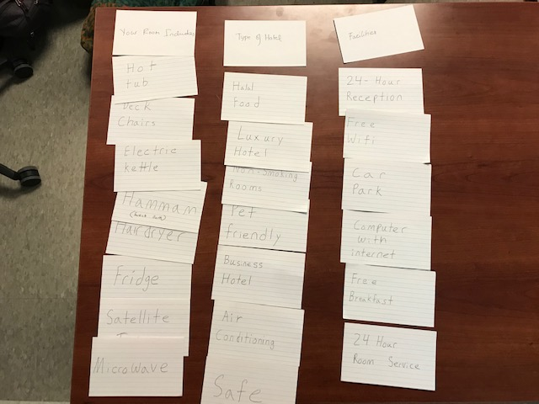

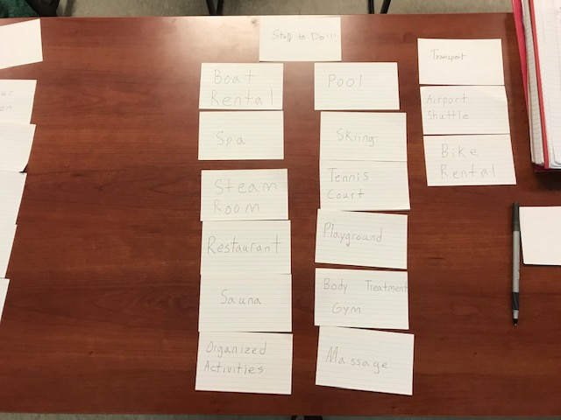

Participant 5

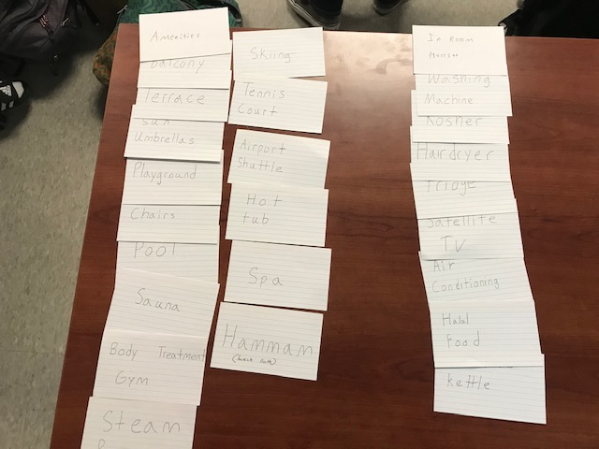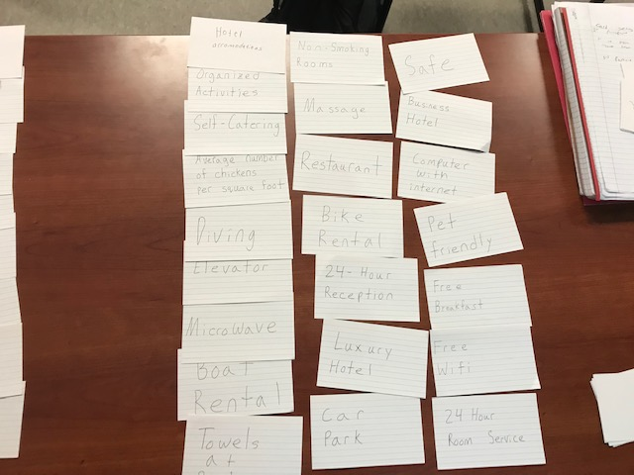

Participant 6

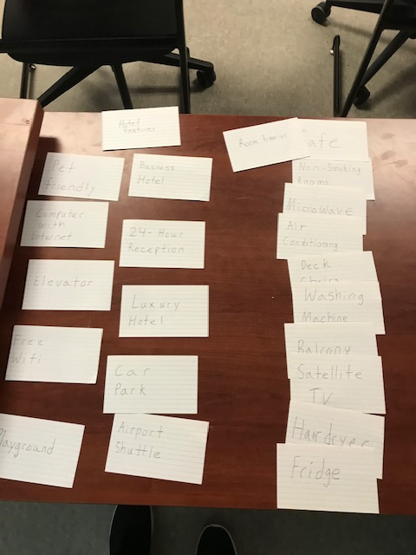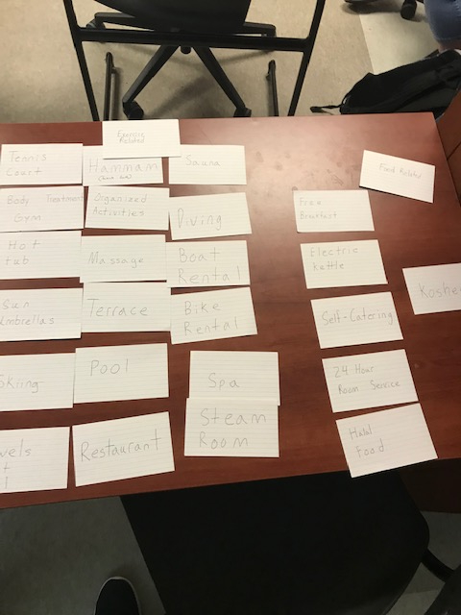

Participant 7

